RAFFLE
Weatherby SA-459 Black Synthetic Semi-Auto Shotgun
Winner will receive $575.00 in Bass Pro Shops gift cards to cover Shotgun cost!!
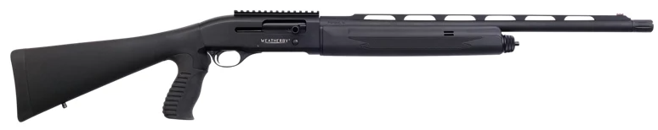
The Weatherby® SA-459 Black Synthetic Semi-Auto Shotgun is a feature-rich tactical shotgun, designed for home defense, law enforcement, and military applications.
The CNC-machined aircraft aluminum receiver is lightweight, yet durable for lasting performance, while the hard-anodized finish offers superior corrosion resistance.
The chrome-plated bolt ensures smooth, flawless function and improved durability, and the enlarged bolt handle offers a reliable grip for large, small, and gloved hands. A dual-valve gas system ensures reliable, clean operation, eliminating the risk of failures. The chrome-lined 22" barrel features a vented top rib, while a green fiber optic front site offers quick, intuitive target acquisition.
A removable 1913 Picatinny rail on the receiver readily accepts a variety of aftermarket scopes, red dots, and iron sights. The drop-out trigger system offers quick, easy cleaning, and a cross-bolt, push-button safety allows for easy manipulation without relinquishing your grip.
A rubberized pistol grip offers improved control and comfort, as well as 1-handed control and improved hip-firing performance. Includes 2 chokes for improved accuracy & performance (Extended, fluted Extra Full).

• CNC-machined aircraft aluminum receiver
• Chrome-plated bolt
• Enlarged bolt handle
• 22" chrome-lined barrel
• Vented rib
• Green fiber optic front sight
• Removable Picatinny receiver mount
• Drop-out trigger system for easy cleaning
• Dual-valve gas system
• Push-button safety
• Synthetic stock with rubberized pistol grip

Manufacturer model #: SA459SY1222PGM

Drawing will be held on Tuesday, January 12th, 2022
You do not need to be present to win. Membership Not Required.
Proceeds will be used for non-profit Veterans’ and Community related activities of S.A.L. Squadron 7

