The last 18 or so months have been difficult at Post 7, with the virus keeping so many members and guests at bay, and the dangers and fears of the virus still hanging around.
Anthony Incantalupo is now Commander. I served longer than I ever expected to (about 6 months), having been rescued by some of the greatest Post 7 members who will help with a transition of post duties. Help them as much as possible. Give them the help and respect for the work they are doing. None of them receive any pay or any other compensation save the honor of serving. I will still be around as much as possible, but after months of long hours, I am taking lots of time off.
Anthony Incantalupo Commander. David Marsh as 1st Vice Commander, Angelo Bottone as 2nd Vice Commander, Thomas Vitelli as Finance Officer, Jimmie Dean as Sgt at Arms, & James Fischer on Adjutant Officer.
My wife, Patricia Cox, is leaving her position also. She has been the Post’s Right Arm. She has done more for the post during the last 6 months than any other one person. The Post could not have survived these critical months without her there. Thank you for letting us serve the Post.
Anthony R. & Patricia M. Cox
Flashback! Saturday Aug 14, 21 & 27th.
MEETING CHANGES
Post 7 E-Board and Member meetings will now be held on the First Tuesday of every month in the Hall. The August 31st Meeting is Cancelled since the September meeting will be only a week later. The Next Regular Member Meeting will be on Tuesday, September 7th.
THURSDAY AFTERNOON BINGO
The Kitchen has been leased out, by UnSinfully Delicious, who have over all kitchen duties. Claire makes wonderfully healthy food that tastes too good to be true. The Kitchen is open Monday, Tuesday and Saturday evenings, soon to be more days & hours.
BOOMER BAND TUESDAY EVENINGS!
MEMBERSHIP
The 2022 Membership Cards are in. I would love to see 100 percent renewals by Veterans’ Day, Thursday, November 11, 2021.

2022 Annual Dues
Legion Post 7 |  | $45.00
Aux Unit 7 |  | $32.00
S.A.L. Squadron 7 (18 & over) |  | $25.00
S.A.L. Squadron 7 (17 & under) |  | $10.00
The Mothers, daughters, grand-mothers, grand-daughters & sisters of an American Legionnaire are eligible to join Auxiliary Unit 7. Adopted and Step are accepted. Ladies in the American Legion are also eligible to join Auxiliary Unit 7. The spouse of an American Legionnaire is eligible to join Auxiliary Unit 7, male or female.
The Male Descendant of an American Legionnaire is eligible to join The Sons of The American Legion. Adopted & Step-sons are accepted.
I am a personally dual member of The American Legion and The Sons of The American Legion. I encourage everyone who is eligible to be a dual member, to do so. It helps support the Legion and the Post.
We need one male Legionnaire who is married to a Legionnaire and the Son of a Legionnaire, to be the first Post 7 Triple Member of the Legion, the S.A.L. and the Auxiliary!
MORE ENTERTAINMENT COMING
I want to thank the entertainers also, Flashback, Sequel, Ann and Jim Purser, Boots & Lace (Jerry and Marilyn Bell, Boomer Band, BandStand, Bill Castner and Lil Ms. Dynamite Karen Kallin and all the other entertainers for all their wonderful music.

LOUNGE
The Lounge is Open at 11AM Mon-Sat
BAR POKER 1PM on Mondays
BAR GAMES 1PM on Wednesday
Got-It GAMES 2PM on Saturdays
SEQUEL
Bill Castner
Lil Ms. Dynamite Karen Kallin
American Legion Baseball
Our baseball team, “Nationals Post 7”, has been my inspiration. The weather has not been cooperating, so a lot of games were cancelled and could not be made up in time for playoffs. Watching us win that double header on Father’s Day was the best time I have had this year. I am proud of them and the work by Team Manager & Head Coach Jordan Banks.
The list below, is of all the team members for Post 7 and Post 252, who were all from the Clearwater Area, Coach Banks coached both teams, and since all or most are from the Clearwater area, here are all of them, in alphabetic order.
American Legion Baseball
# | Name | Position | Post
43 | John Becraft | 1st Base | 7
15 | Logan Bigue | Right Field | 7
12 | Shawn Blanton | Right Field | 7
11 | Dylan Bond | 1st Base | 252
42 | Richard Boykins | Shortstop | 7
22 | Levi Campos | 2nd Base | 7
19 | Carter Corallino | 1st Base | 7
3 | Sean Davis | Shortstop | 7
11 | Braeden Foster | Catcher | 7
10 | Matthew Gluchowski | Left Field | 252
15 | Robert Hull | 2nd Base | 252
42 | Derrick Hunter | Right Field | 252
1 | Keenan Jack | 2nd Base | 7
2 | Colin Kauble | Left Field | 7
99 | Peyton Kauble | Pitcher | 7
28 | Chance Kelly | 3rd Base | 252
23 | Ryan Kimmet | 2nd Base | 252
4 | Slayde Kinzinger | Pitcher | 252
8 | Andrew Lefleur | 3rd Base | 7
16 | Aaron Leon | 1st Base | 7
7 | Bryan Loos | 3rd Base | 252
6 | Corey "CJ" Moore | Center Field | 252
9 | Cain Pagley | Catcher | 252
17 | Michael Ohanlan | 1st Base | 7
27 | Daniel Peralta | Shortstop | 252
34 | Tyler Radzadus | Pitcher | 252
12 | Nelson Taylor | Center Field | 252
18 | Jacob Thomas | Pitcher | 252
7 | Caleb Vives | Shortstop | 7
30 | Tyler Warbrock | Pitcher | 252
5 | Zach Werling | Pitcher | 7
10 | Davis Weppler | Shortstop | 7
3 | Evan White | 2nd Base | 252
17 | James White | Pitcher | 252
13 | Kyle Wilhelm | 2nd Base | 252
6 | Ty Woodring | 2nd Base | 7
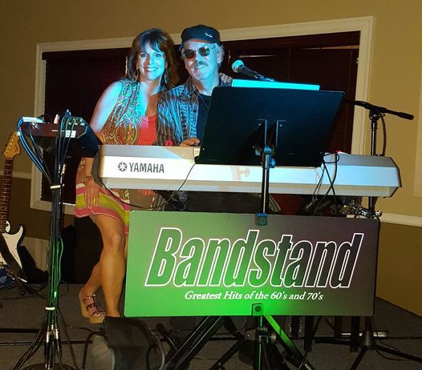
REGULAR MONTHLY MEETINGS
E-Board ~ 1st Tuesday at 6:30PM
Post ~ 1st Tuesday at 7:00PM
S.A.L. ~ 2nd Wednesday at 7:00PM
Auxiliary ~ 3rd Tuesday at 6:00PM
There will be no Regard E-board or Post member meeting in August due to the date changes. The Auxiliary and S.A.L. Meetings have not changed.
Only Members in good standing have voice and vote at member meetings.
NOTICES
Turner – Brandon Post #7, Incorporated The American Legion Clearwater, Florida, and the Post 7 Auxiliary are Not-for-Profit corporations under Chapter 617 of Florida Statutes, and are non-profit organizations under IRS Code 501(c)(19).
Auxiliary Unit 7 is incorporated separately as a Not-for-Profit Corporation in Florida. S.A.L. Squadron 7 is a program under Turner-Brandon Post 7.
None of the Officers or Board are paid or receive any compensation for their work.
This Post 7 Newsletter is a monthly periodical. Please submit newsletter articles no later than the 20th.

